* **Backup Prerequisites:**
* Take the backup of current package body for SHAW_OM_POS_LGF_PKG for recovery process.
* Go to the URL:- https://shawicsprod-a444774.integration.us2.oraclecloud.com/ics/
* Enter the credentials and login
* Go to Task – Integrations – Designer – Integrations.
* Search for Integration – “SHAW OM PointOfSales From Cloud to LogFire”
* Deactivate the Integration

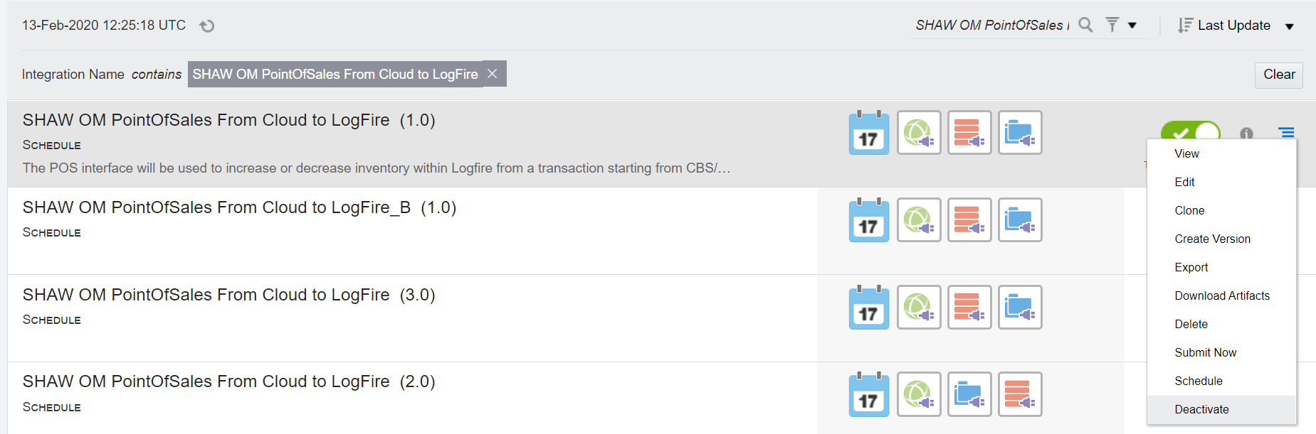

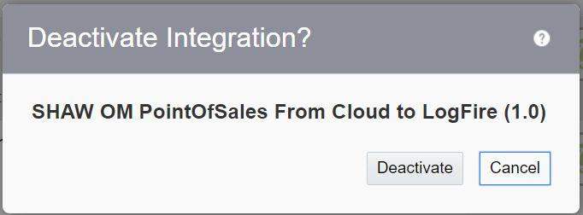

* **Installation:**
* Open Production DBCS connection in SQL Developer/Toad.
* Get the files from Git with below mentioned path and latest version
* Compile the package body : cloud-erp\Interfaces\LOG-INT-18\Developed Components\DB\SHAW_OM_POS_LGF_PKG.pkb
* Once Compiled Successfully, Activate the Integration

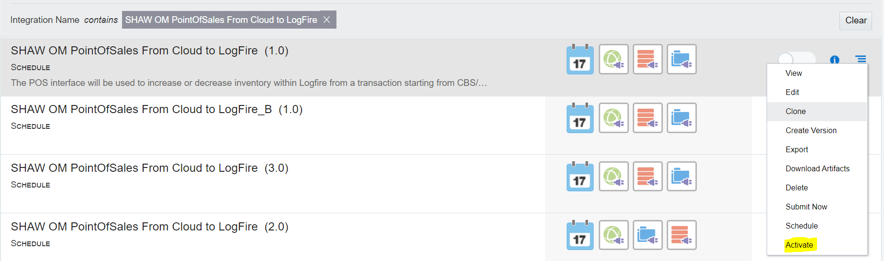

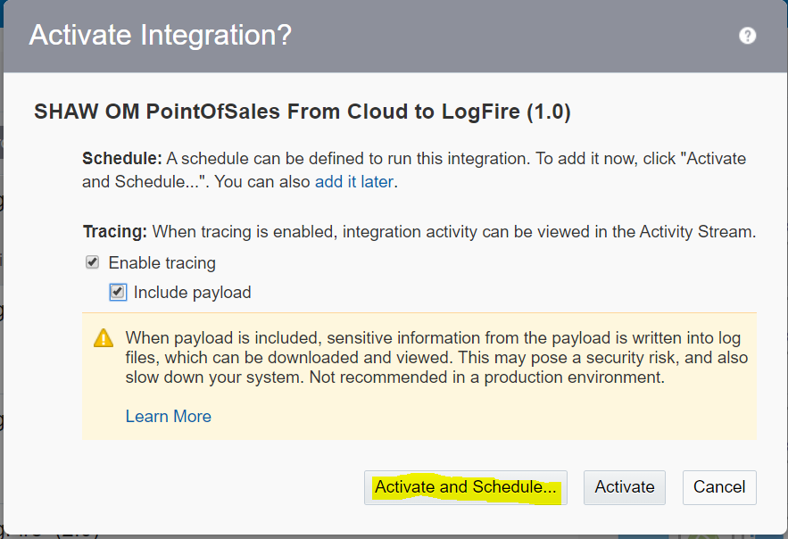

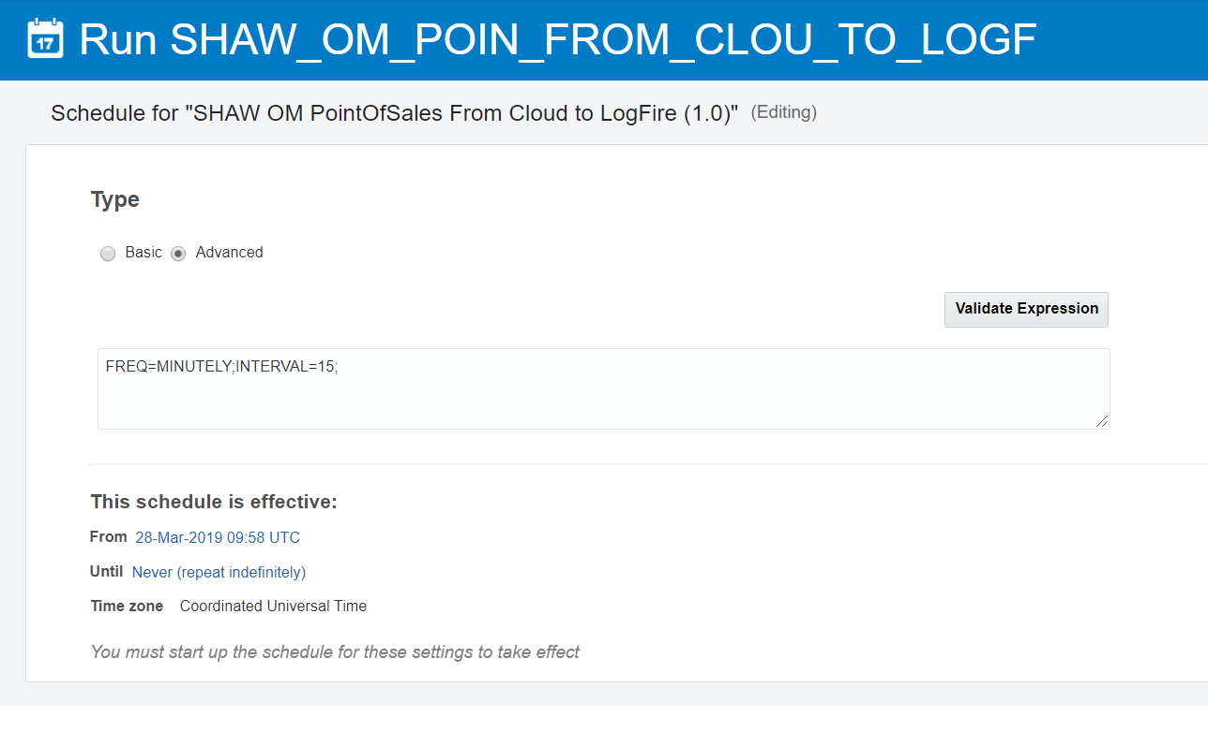

* **Recovery Steps**

In case of any issues follow the below steps to recover back to the old code. Use the backup code for the below steps.

* Compile the package body for SHAW_OM_POS_LGF_PKG, taken as backup in in prerequisite steps.